**1. Punjab Kings (formerly Kings XI Punjab) is an IPL cricket team based in Mohali, Punjab.**

**2. The franchise was established in 2008 and is jointly owned by Mohit Burman, Ness Wadia, Preity Zinta, and Karan Paul.**

**3. The team plays its home matches at the PCA Stadium in Mohali and has also played in Dharamsala and Indore.**

**4. They topped the league table and finished as runners-up in the 2014 IPL season.**

**5. Punjab Kings made their only other playoff appearance in the IPL in 13 seasons.**

**6. They participated in the Champions League Twenty20 in 2014 and reached the semi-finals.**

**7. The team changed its name from Kings XI Punjab to Punjab Kings in February 2021.**

**8. In the 2022 IPL auction, Punjab Kings made the highest-ever bid in IPL history, acquiring Sam Curran for Rs 18.50 crores.**

**9. The franchise was purchased for $76 million in the 2008 auction.**

**10. The catchment areas for the team included Kashmir, Jammu, Himachal Pradesh, Punjab, and Haryana.**

**11. The team's logo features the letter sequence "K J H P H" representing the catchment areas.**

**12. Punjab Kings have had limited success in the IPL, with only two playoff appearances in their history.**

**13. The team has a strong fan base and is known for its passionate supporters.**

**14. Punjab Kings have had several notable players representing them over the years, including Yuvraj Singh, Virender Sehwag, and Glenn Maxwell.**

**15. The franchise continues to participate in the IPL, striving for greater success in future seasons.**

**Expulsion from the IPL and return**

**1. In 2010, the franchise contracts of Kings XI Punjab and Rajasthan Royals were terminated by the Indian Premier League (IPL) due to the controversy surrounding the BCCI and Lalit Modi.**

**2. Kings XI Punjab and Rajasthan Royals announced that they would take legal action to remain in the IPL.**

**3. Kings XI Punjab was reinstated with the involvement of the High Court after initially being terminated by the IPL.**

**Name change**[[edit](https://en.wikipedia.org/w/index.php?title=Punjab_Kings&action=edit&section=3)]

Kings XI Punjab was renamed to Punjab Kings on 17 February 2021 ahead of the 2021 Indian Premier League season. The decision to change the name was made to rebrand and "relook at things" after 13 seasons without winning a title. The name change had been planned for two years prior, with the announcement delayed due to the COVID-19 pandemic.

he team plays its home matches at the Inderjit Singh Bindra Stadium, Mohali. Indian Premier League (IPL) is an the top-level professional Twenty20 cricket league in India, organized by the Board of Control for Cricket in India (BCCI).

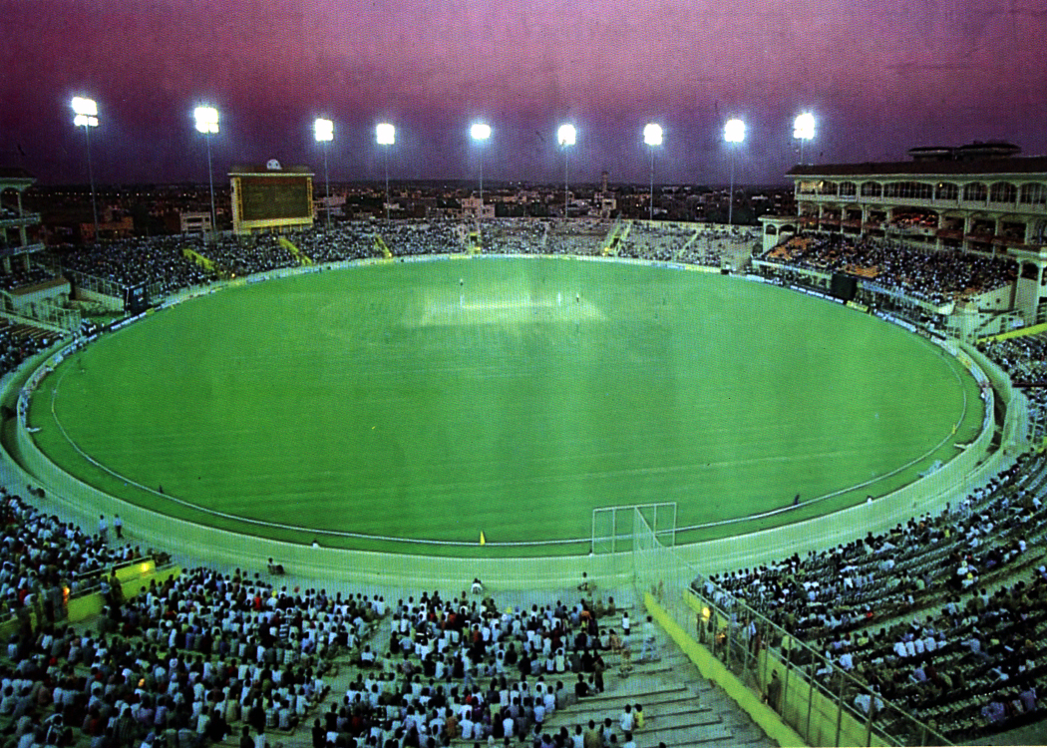

the stadium also hosted some IPL matches as a home stadium for Kings XI Punjab. The picturesque venue is unique in India as it is situated at an altitude of 1,457 m above the sea level and has the snow-capped Himalayan mountains in the background.

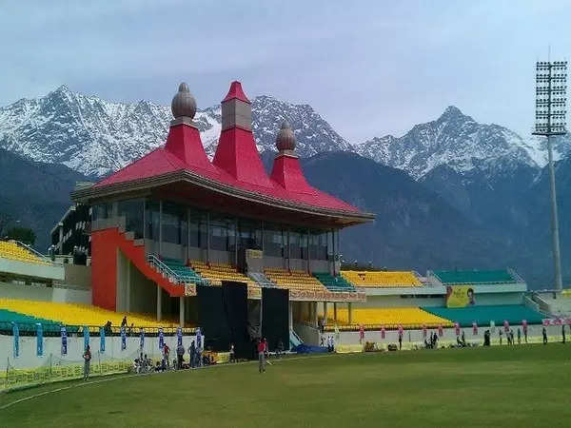

Administration and support staff[[edit](https://en.wikipedia.org/w/index.php?title=Punjab_Kings&action=edit&section=25)]

|  |  |
| --- | --- |
| **Position** | **Name** |
| CEO | [Satish Menon](https://en.wikipedia.org/wiki/Satish_Menon) |
| Team manager | Vikram Hastir |
| Head coach | [Trevor Bayliss](https://en.wikipedia.org/wiki/Trevor_Bayliss) |
| Assistant coach | [Brad Haddin](https://en.wikipedia.org/wiki/Brad_Haddin) |
| Batting coach | [Wasim Jaffer](https://en.wikipedia.org/wiki/Wasim_Jaffer) |
| Spin bowling coach | [Sunil Joshi](https://en.wikipedia.org/wiki/Sunil_Joshi) |
| Fast bowling coach | [Charl Langeveldt](https://en.wikipedia.org/wiki/Charl_Langeveldt) |
| Fielding coach | [Trevor Gonsalves](https://en.wikipedia.org/w/index.php?title=Trevor_Gonsalves&action=edit&redlink=1) |
| Team Physiotherapist | [Andrew Leipus](https://en.wikipedia.org/wiki/Andrew_Leipus) |
| Strength and conditioning coach | Adrian Le Roux |

Statistics[[edit](https://en.wikipedia.org/w/index.php?title=Punjab_Kings&action=edit&section=27)]

*See also:*[*List of Punjab Kings records*](https://en.wikipedia.org/wiki/List_of_Punjab_Kings_records)

**Performance summary**[[edit](https://en.wikipedia.org/w/index.php?title=Punjab_Kings&action=edit&section=28)]

|  |  |  |  |  |  |
| --- | --- | --- | --- | --- | --- |
| **Year** | **Matches** | **Wins** | **Losses** | **No result** | **% win** |
| [2008](https://en.wikipedia.org/wiki/2008_Indian_Premier_League) | 15 | 10 | 5 | 0 | 66.66% |
| [2009](https://en.wikipedia.org/wiki/2009_Indian_Premier_League) | 14 | 7 | 7 | 0 | 50.00% |
| [2010](https://en.wikipedia.org/wiki/2010_Indian_Premier_League) | 14 | 3 | 10 | 1 | 21.43% |
| [2011](https://en.wikipedia.org/wiki/2011_Indian_Premier_League) | 14 | 7 | 7 | 0 | 50.00% |
| [2012](https://en.wikipedia.org/wiki/2012_Indian_Premier_League) | 16 | 8 | 8 | 0 | 50.00% |
| [2013](https://en.wikipedia.org/wiki/2013_Indian_Premier_League) | 16 | 8 | 8 | 0 | 50.00% |
| [2014](https://en.wikipedia.org/wiki/2014_Indian_Premier_League) | 17 | 12 | 5 | 0 | 70.58% |
| [2015](https://en.wikipedia.org/wiki/2015_Indian_Premier_League) | 14 | 3 | 10 | 1 | 21.43% |
| [2016](https://en.wikipedia.org/wiki/2016_Indian_Premier_League) | 14 | 4 | 10 | 0 | 28.57% |
| [2017](https://en.wikipedia.org/wiki/2017_Indian_Premier_League) | 14 | 7 | 7 | 0 | 50.00℅ |
| [2018](https://en.wikipedia.org/wiki/2018_Indian_Premier_League) | 14 | 6 | 8 | 0 | 42.85℅ |
| [2019](https://en.wikipedia.org/wiki/2019_Indian_Premier_League) | 14 | 6 | 8 | 0 | 42.85℅ |
| [2020](https://en.wikipedia.org/wiki/2020_Indian_Premier_League) | 14 | 6 | 8 | 0 | 42.85% |
| [2021](https://en.wikipedia.org/wiki/2021_Indian_Premier_League) | 14 | 6 | 8 | 0 | 42.85% |
| [2022](https://en.wikipedia.org/wiki/2022_Indian_Premier_League) | 14 | 7 | 7 | 0 | 50.00% |
| [2023](https://en.wikipedia.org/wiki/Punjab_Kings_in_2023) | 14 | 6 | 8 | 0 | 42.85% |
| **Total** | **232** | **106** | **124** | **2** | **45.69%** |

Last updated: 16 May 2023

**Opposition in Indian Premier League**[[edit](https://en.wikipedia.org/w/index.php?title=Punjab_Kings&action=edit&section=29)]

|  |  |  |  |  |  |  |
| --- | --- | --- | --- | --- | --- | --- |
| **Teams** | **Matches** | **Won** | **Lost** | **Tied** | **No result** | **% win** |
| [Chennai Super Kings](https://en.wikipedia.org/wiki/Chennai_Super_Kings) | 29 | 13 | 16 | 0 | 0 | 44.83% |
| [Delhi Capitals](https://en.wikipedia.org/wiki/Delhi_Capitals) | 30 | 15 | 15 | 0 | 0 | 50.00℅ |
| [Kolkata Knight Riders](https://en.wikipedia.org/wiki/Kolkata_Knight_Riders) | 32 | 11 | 21 | 0 | 0 | 34.37% |
| [Mumbai Indians](https://en.wikipedia.org/wiki/Mumbai_Indians) | 31 | 15 | 16 | 0 | 0 | 48.39% |
| [Rajasthan Royals](https://en.wikipedia.org/wiki/Rajasthan_Royals) | 25 | 11 | 14 | 0 | 0 | 44.00% |
| [Royal Challengers Bangalore](https://en.wikipedia.org/wiki/Royal_Challengers_Bangalore) | 31 | 17 | 14 | 0 | 0 | 54.83% |
| [Sunrisers Hyderabad](https://en.wikipedia.org/wiki/Sunrisers_Hyderabad) | 21 | 7 | 14 | 0 | 0 | 33.33℅ |
| [Deccan Chargers](https://en.wikipedia.org/wiki/Deccan_Chargers) | 10 | 7 | 3 | 0 | 0 | 70.00℅ |
| [Gujarat Lions](https://en.wikipedia.org/wiki/Gujarat_Lions) | 4 | 2 | 2 | 0 | 0 | 50.00% |
| [Kochi Tuskers Kerala](https://en.wikipedia.org/wiki/Kochi_Tuskers_Kerala) | 1 | 1 | 0 | 0 | 0 | 100.00% |
| [Pune Warriors India](https://en.wikipedia.org/wiki/Pune_Warriors_India) | 6 | 3 | 3 | 0 | 0 | 50.00% |
| [Rising Pune Supergiant](https://en.wikipedia.org/wiki/Rising_Pune_Supergiant) | 4 | 2 | 2 | 0 | 0 | 50.00% |
| Total | 224 | 104 | 120 | 0 | 0 | 46.43% |